NAME/SURNAME: İREM AŞUTKALIOĞLU DATE: 26/10/2020

ID NUMBER: 2284123 SECTİON: 2

**THE CELL**

**1-) INTRODUCTION:**

Cell which is in the biology term is the basic unit of life and there have been all the living things. Also, all the vital activities carried out in cells (Cell | Definition, Types, & Functions, 2020). Plasma membrane, cytoplasm, DNA, and ribosome have been existing all the cells (Cell Structure | Protocol, 2020). Plasma membrane which cover the cell support for selectively permeable and this structure is the thin and fluid layer. There are organelles and cytoplasm (containing salt, organic molecule, and other compound) in the area which is surround by plasma membrane. Ribosome provide the production of the proteins. Also, the organelles do not have membrane bound. Therefore, that can be exist all the cell type which name is prokaryotes and eukaryotes. Prokaryotes are the basic organisms. They are microscopic single-celled organism and, they do not include distinct nucleus with membrane and other specialist organelles. Bacteria and archaea are the member of prokaryotic cells (Laurence A. Cole, in Biology of Life, 2016). When eukaryotic cells and prokaryotic cells are compared, eukaryotic cells appear to be more complex. These complex structures provide energy balance, metabolism and, gene expression (Intro to eukaryotic cells (article) | Cells | Khan Academy, 2020). Eukaryotic cells’ components are nucleus, the cytoskeleton which is the network of protein filaments (cell structure, cell movement, transport of the materials). These cells can include nucleus, mitochondria, chloroplast, chromoplast, endoplasmic reticulum, the Golgi complex, the lysosome, the peroxisome, vacuoles, ribosome, and cell walls.

Staining techniques provide better visual and distinguish between dead and live cells. This dye stains the cells and highlights the certain areas. Therefore, we can see all part clearer. Methylene blue is used for staining animal cells to observe more visible nuclei. Iodine is used as starch indicator. If solution is included starch, starch and iodine turn a dark blue color (Microscopy, 2020). Janus green B is used to stain mitochondria. (Coopperstein, Dixit and Lazarow, 1960)

**2-) METHOD:**

Firstly, the microscope, which is going to use and its lenses, stage must be cleaned with cotton. Then, plugin the microscope and turn out the light source. Necessary adjustments are made such as rotating nosepiece, stage level, and lowest magnification. Sample put in the slide and water is poured on it. The sample must be all wet. After that part, sample is observed 4X, 10X and 40X. Then, sample is stained with dye. In these experiments, Janus Green B, methylene blue, and iodine are used. After the staining, the area of the slide except samples are cleaned with absorbent paper towel. Then, again observe the samples.

**3-) RESULT:**

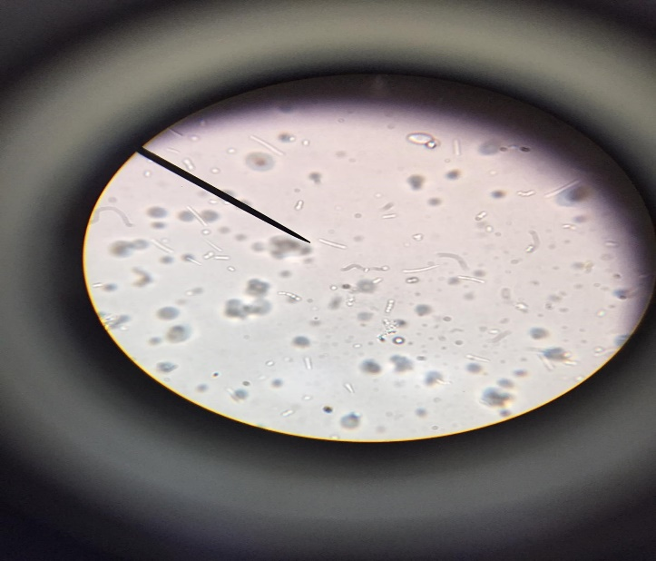

BACTERIA

**3.1.1. The yogurt cells, 100X**

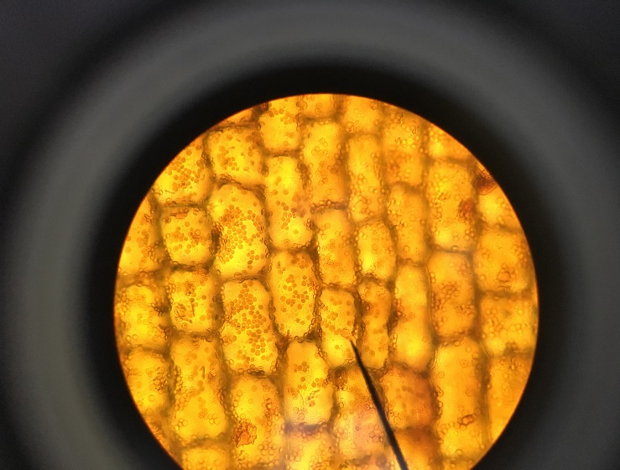

CHOLOROPLAST

NUCLEUS

MIDDLE LAMELLA

**3.1.2 The elodea cells, 40X**

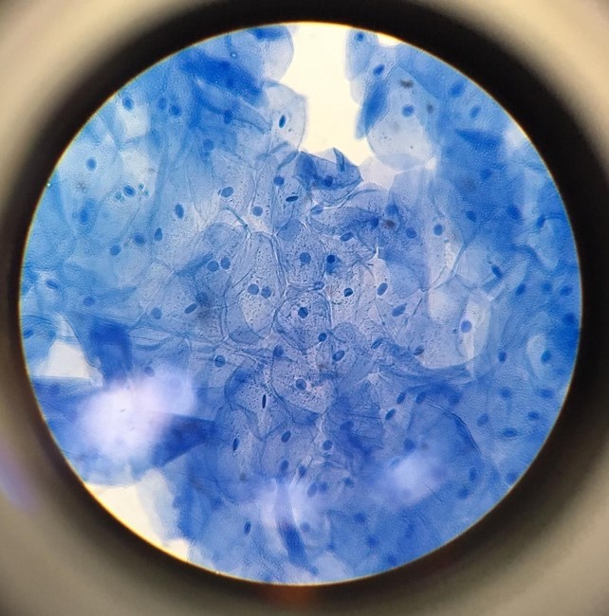

NUCLEUS

CELL MEMBRANE

**3.1.3. The epithelial, 40X**

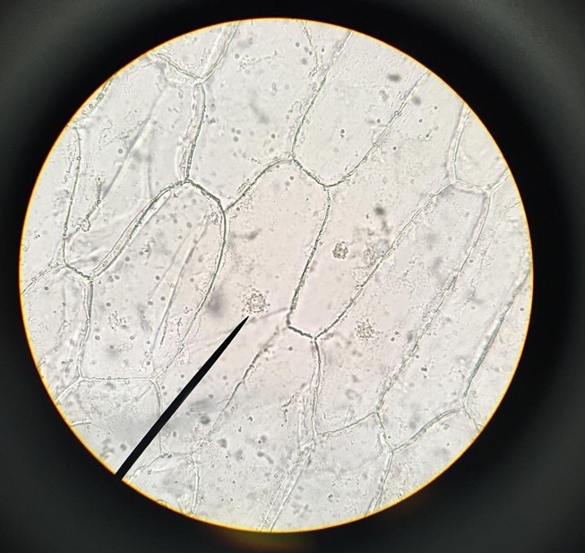

NUCLEUS

CELL WALL

**3.1.4. Onion cells, 4X**

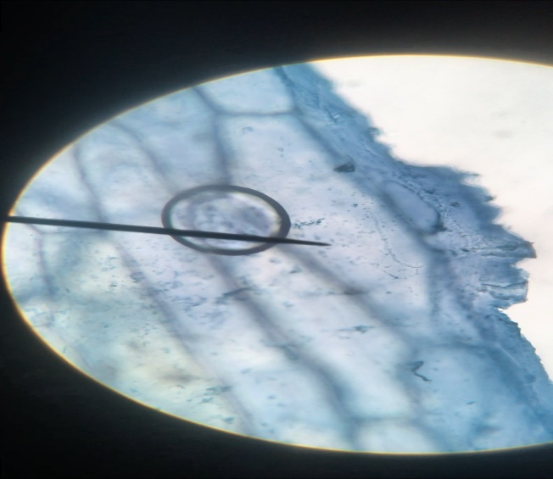

CELL WALL

NUCLEUS

**3.1.5. Onion cells with Janus Green B, 40X**

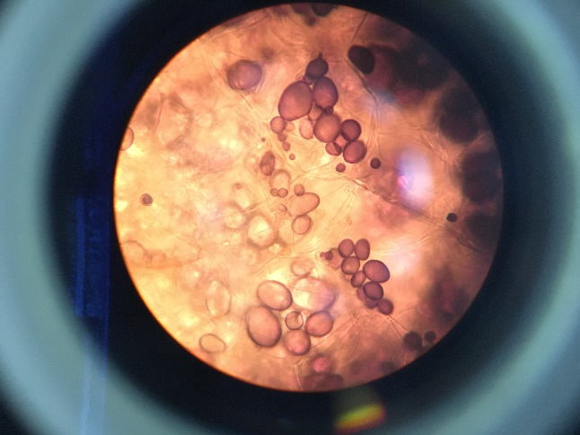

CELL MEMBRANE

NUCLEUS

**3.1.6. Potato cells with Iodine, 40X**

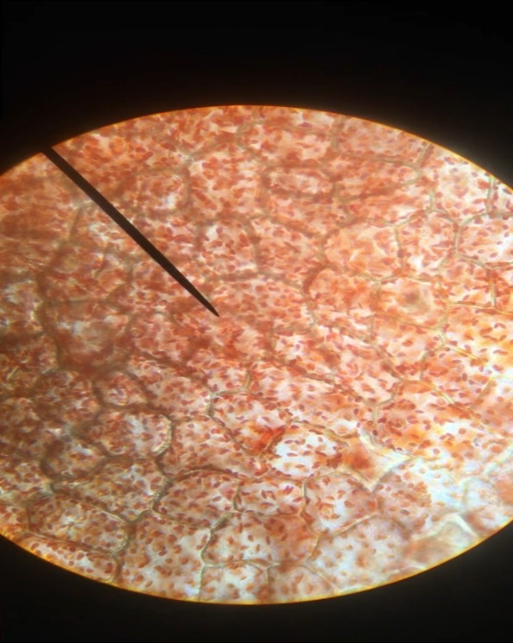

CHROMOPLAST

CELL WALL

**3.1.7. Red pepper, 40X**

**DISCUSSION:**

Methylene blue which is the dark odorless dye is dissolve the water and chloroform and it is dissolve slightly amount of alcohol. In water, methylene blue has a positive charge. When DNA interacts with methylene blue, their opposite charges attract. This situation leads to rings of the methylene blue move down between DNA latter rungs. Therefore, the cell nucleus takes the rich blue color and it looks like a point with blue color. (Methylene Blue, Part 1: The Biologist's Dye, 2020). Janus Green B dye is used for staining mitochondria and, it provides realize reduction and oxidation reaction which present the electron transfer chain alteration. The defect in electron transfer chain of mitochondria by paraquat is linked to free radical formation (Using Janus green B to study paraquat toxicity in rat liver mitochondria: role of ACE inhibitors (thiol and nonthiol ACEi)., 2007). In the iodine staining, charge transfer complexes allow color change to occur. Molecular iodine (I2) is not easily soluble in water, so potassium iodine should be added. Together, they form polyiodide ions of the type In–, for example, I3–, I5–, or I7–. Iodide is the negatively charge in these compounds which is behaved a charge acceptor. Electrons which is in charge-transfer complexes are easy to higher level of energy with helping the light. Therefore, electrons absorb the light and human eye can see cells with more detailed and the change of color (Goedecke, 2016).

There can be lots of problem such as the sample may not get wet enough and bubble may occur. Firstly, we talk why we use the water on the sample. When we out into water on the sample, our cells take in water because of osmotic pressure and when the cells swell, the image will look much clearer. Also, when the cells swell, movement of inside of cells is increased. Therefore, clearer image is seen. The other problem which can be occur is bubbles on the slide. While cower slip put into the slide, we should be careful. Because if bubbles occur, image does not visible anymore. Bubbles block to us about the visibility. Therefore, we careful about these problems.

Mitochondria is about 0.5-1μm (Alberts et al., 2020). Also, bacteria are about 0.3-5μm (Measuring Up, 2020). The human eyes can see minimum 50-60μm (Filtration | Nilfisk Industrial Vacuums, 2020). Therefore, we understand that the mitochondria and bacteria are so small. There are huge differences between mitochondria or bacteria and the size which is the human eyes can see. Due to this difference, we should use high magnitude to observe mitochondria and bacteria.

**REFERANCES:**

Encyclopedia Britannica. 2020. *Cell | Definition, Types, & Functions*. [online] Available at: <https://www.britannica.com/science/cell-biology> [Accessed 28 October 2020].

Jove.com. 2020. *Cell Structure | Protocol*. [online] Available at: <https://www.jove.com/science-education/10587/cell-structure#:~:text=All%20cells%20share%20common%20features,bilayer%20that%20surrounds%20the%20cell.> [Accessed 28 October 2020].

Cole, L., 2016. *Prokaryote - An Overview | Sciencedirect Topics*. [online] Sciencedirect.com. Available at: <https://www.sciencedirect.com/topics/biochemistry-genetics-and-molecular-biology/prokaryote> [Accessed 28 October 2020].

Khan Academy. 2020. *Intro To Eukaryotic Cells (Article) | Cells | Khan Academy*. [online] Available at: <https://www.khanacademy.org/science/high-school-biology/hs-cells/hs-prokaryotes-and-eukaryotes/a/intro-to-eukaryotic-cells> [Accessed 28 October 2020].

Microscopy. 2020. *Microscopy*. [online] Available at: <https://serc.carleton.edu/microbelife/research_methods/microscopy/index.html> [Accessed 28 October 2020].

Coopperstein, S., Dixit, P. and Lazarow, A., 1960. *Studies On The Mechanism Of Janus Green B Staining Of Mitochondria. IV. Reduction Of Janus Green B By Isolated Cell Fractions*. [online] Wiley Online Library. Available at: <https://onlinelibrary.wiley.com/doi/abs/10.1002/ar.1091380107> [Accessed 23 February 2005].

Chlorine.americanchemistry.com. 2020. *Methylene Blue, Part 1: The Biologist's Dye*. [online] Available at: <https://chlorine.americanchemistry.com/Science-Center/Chlorine-Compound-of-the-Month-Library/Methylene-Blue-Part-1-The-Biologists-Dye/#:~:text=In%20water%2C%20methylene%20blue%20has,location%20of%20the%20cell%20nucleus.> [Accessed 31 October 2020].

2007. *Using Janus Green B To Study Paraquat Toxicity In Rat Liver Mitochondria: Role Of ACE Inhibitors (Thiol And Nonthiol Acei).*. [online] Available at: <https://www.sigmaaldrich.com/catalog/papers/17384251> [Accessed 23 March 2007].

Goedecke, C., 2016. *Why Does Iodine Turn Starch Blue? :: Education :: Chemistryviews*. [online] Chemistryviews.org. Available at: <https://www.chemistryviews.org/details/education/10128441/Why_Does_Iodine_Turn_Starch_Blue.html#:~:text=Iodine%20Test,changes%20to%20a%20deep%20blue.> [Accessed 6 December 2016].

Alberts B, Johnson A, Lewis J, et al. Molecular Biology of the Cell. 4th edition. New York: Garland Science; 2002. The Mitochondrion. Available from: <https://www.ncbi.nlm.nih.gov/books/NBK26894/>

Nilfiskcfm.com. 2020. *Filtration | Nilfisk Industrial Vacuums*. [online] Available at: <https://nilfiskcfm.com/filtration/#:~:text=On%20average%2C%20the%20human%20eye,often%20causing%20adverse%20health%20effects.> [Accessed 31 October 2020].

Small Things Considered. 2020. *Measuring Up*. [online] Available at: <https://schaechter.asmblog.org/schaechter/2015/08/measuring-up.html#:~:text=Bacteria%20generally%20range%20from%200.3,10%20to%2020%20times%20wider.> [Accessed 31 October 2020].